Chapter 8, Solution 25.

Using Fig. 8.78, design a problem to help other students to better understand source-free RLC circuits.

Although there are many ways to work this problem, this is an example based on the same kind of problem asked in the third edition.

Problem

In the circuit in Fig. 8.78, calculate i_{o}(t) and v_{o}(t) for t > 0.

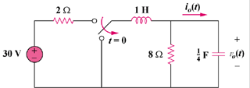

Figure 8.78

Solution

In the circuit in Fig. 8.76, calculate i_{o}(t) and v_{o}(t) for t>0.

2 Ω
8 Ω
30V

+
−
1 H
(1/4)F
i_{o}(t)

+

v_{o}(t)

−

t=0, note this is a make before break switch so the inductor current is not interrupted.

Figure 8.78 For Problem 8.25.

At t = 0⁻, v_{o}(0) = (8/(2 + 8)(30) = 24

For t > 0, we have a source-free parallel RLC circuit.

- = 1/(2RC) = ¼

ω_{o} = 1/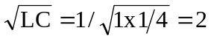

Since α is less than ω_{o}, we have an under-damped response.

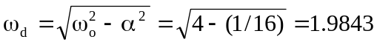

v_{o}(t) = (A₁cosω_{d}t + A₂sinω_{d}t)e^{-αt}

v_{o}(0) = 30(8/(2+8)) = 24 = A₁ and i_{o}(t) = C(dv_{o}/dt) = 0 when t = 0.

dv_{o}/dt = -α(A₁cosω_{d}t + A₂sinω_{d}t)e^{-αt} + (-ω_{d}A₁sinω_{d}t + ω_{d}A₂cosω_{d}t)e^{-αt}

at t = 0, we get dv_{o}(0)/dt = 0 = -αA₁ + ω_{d}A₂

Thus, A₂ = (α/ω_{d})A₁ = (1/4)(24)/1.9843 = 3.024

v_{o}(t) = (24cos1.9843t + 3.024sin1.9843t)e^{-t/4} volts.

i₀(t) = Cdv/dt = 0.25[–24(1.9843)sin1.9843t + 3.024(1.9843)cos1.9843t – 0.25(24cos1.9843t) – 0.25(3.024sin1.9843t)]e^{–t/4}
= [– 12.095sin1.9843t]e^{–t/4} A.

